Drawing Objects in the World

After completing this chapter, you will be able to:

* Create and draw multiple rectangular objects
* Control the position, size, rotation, and color of the created rectangular objects
* Define a coordinate system to draw from
* Define a target subarea on the canvas to draw to
* Work with abstract representations of Renderable objects, transformation operators, and cameras

# Introduction

Ideally, a video game engine should provide proper abstractions to support designing and building games in meaningful contexts. For example, when designing a soccer game, instead of a single square with a fixed ±1.0 drawing range, a game engine should provide proper utilities to support designs in the context of players running on a soccer field. This high-level abstraction requires the encapsulation of basic operations with data hiding and meaningful functions for setting and receiving the desired results.

While this book is about building abstractions for a game engine, this chapter focuses on creating the fundamental abstractions to support drawing. Based on the soccer game example, the support for drawing in an effective game engine would likely include the ability to easily create the soccer players, control their size and orientations, and allow them to be moved and drawn on the soccer field. Additionally, to support proper presentation, the game engine must allow drawing to specific subregions on the canvas so that a distinct game status can be displayed at different subregions, such as the soccer field in one subregion and player statistics and scores in another subregion.

This chapter identifies proper abstraction entities for the basic drawing operations, introduces operators that are based on foundational mathematics to control the drawing, overviews the WebGL tools for configuring the canvas to support subregion drawing, defines JavaScript classes to implement these concepts, and integrates these implementations into the game engine while maintaining the organized structure of the source code.

# Encapsulating Drawing

Although the ability to draw is one of the most fundamental functionalities of a game engine, the details of how drawings are implemented are generally a distraction to gameplay programming. For example, it is important to create, control the locations of, and draw soccer players in a soccer game. However, exposing the details of how each player is actually defined (by a collection of vertices that form triangles) can quickly overwhelm and complicate the game development process. Thus, it is important for a game engine to provide a well-defined abstraction interface for drawing operations.

With a well-organized source code structure, it is possible to gradually and systematically increase the complexity of the game engine by implementing new concepts with localized changes to the corresponding folders. The first task is to expand the engine to support the encapsulation of drawing such that it becomes possible to manipulate drawing operations as a logical entity or as an object that can be rendered.

**Note** In the context of computer graphics and video games, the word *render* refers to the process of changing the color of pixels corresponding to an abstract representation. For example, in the previous chapter, you learned how to render a square.

## The Renderable Objects Project

This project introduces the Renderable class to encapsulate the drawing operation. Over the next few projects you will learn more supporting concepts to refine the implementation of the Renderable class such that multiple instances can be created and manipulated. Figure 3-1 shows the output of running the Renderable Objects project. The source code to this project is defined in the chapter3/3.1.renderable_objects folder.

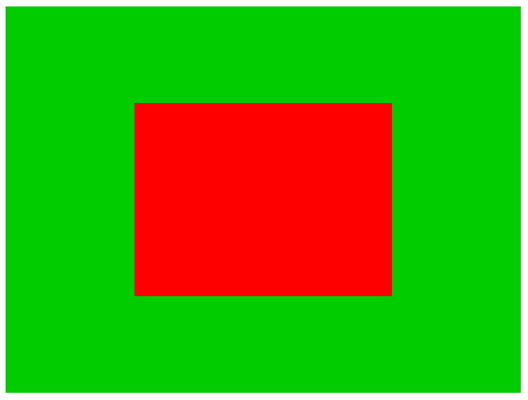

Figure 3-1. Running the Renderable Objects project

The goals of the project are as follows:

* To reorganize the source code structure in anticipation for functionality increases
* To support game engine internal resource sharing
* To introduce a systematic interface for the game developer via the index.js file
* To begin the process of building a class to encapsulate drawing operations by first abstracting the related drawing functionality
* To demonstrate the ability to create multiple Renderable objects

### Source Code Structure Reorganization

Before introducing additional functionality to the game engine, it is important to recognize some shortfalls of the engine source code organization from the previous project. In particular, take note of the following.

1. The core.js source code file contains the WebGL interface, engine initialization, and drawing functionalities. These should be modularized to support the anticipated increase in system complexity.
2. A system should be defined to support the sharing of game engine internal resources. For example, SimpleShader is responsible for interfacing from the game engine to the GLSL shader compiled from the simple_vs.glsl and simple_fs.glsl source code files. Since there is only one copy of the compiled shader, there only needs to be a single instance of the SimpleShader object. The game engine should facilitate this by allowing the convenient creation and sharing of the object.
3. As you have experienced, the JavaScript export statement can be an excellent tool for hiding detailed implementations. However, it is also true that determining which classes or modules to import from a number of files can be confusing and overwhelming in a large and complex system, such as the game engine you are about to develop. An easy to work with and systematic interface should be provided such that the game developer, users of the game engine, can be insulated from these details.

In the following section, the game engine source code will be reorganized to address these issues.

#### Define a WebGL Specific Module

The first step in source code reorganization is to recognize and isolate functionality that is internal and should not be accessible by the clients of the game engine.

1. In your project, under the src/engine folder, create a new folder and name it core. Form this point forward, this folder will contain all functionality that is internal to the game engine and will not be exported to the game developers.
2. You can cut and paste the vertex_buffer.js source code file from the previous project into the src/engine/core folder. The details of the primitive vertices are internal to the game engine and should not be visible or accessible by the clients of the game engine.
3. Create a new source code file in the src/engine/core folder, name it gl.js, and define WebGL’s initialization and access methods.

"use strict"

let mCanvas = null;

let mGL = null;

function get() { return mGL; }

function init(htmlCanvasID) {

mCanvas = document.getElementById(htmlCanvasID);

if (mCanvas == null)

throw new Error("Engine init [" + htmlCanvasID + "] HTML element id not found");

// Get the standard or experimental webgl and binds to the Canvas area

// store the results to the instance variable mGL

mGL = mCanvas.getContext("webgl2") || mCanvas.getContext("experimental-webgl2");

if (mGL === null) {

document.write("<br><b>WebGL 2 is not supported!</b>");

return;

}

}

export {init, get}

Notice that the init() function is identical to the initWebGL() function in core.js from the previous project. Unlike the previous core.js source code file, the gl.js file contains only WebGL specific functionality.

#### Define a System for Internal Shader Resource Sharing

Since only a single copy of the GLSL shader is created and compiled from the simple_vs.glsl and simple_fs.glsl source code files, only a single copy of SimpleShader object is required within the game engine to interface with the compiled shader. You will now create a simple resource sharing system to support future additions of different types of shaders.

Create a new source code file in the src/engine/core folder, name it shader_resources.js, and define the creation and accessing methods for SimpleShader.

**Note** Recall from the previous chapter that the SimpleShader class is defined in the simple_shader.js file which is located in the src/engine folder. Remember to copy all relevant source code files from the previous project.

"use strict";

import SimpleShader from "../simple_shader.js";

// Simple Shader

let kSimpleVS = "src/glsl_shaders/simple_vs.glsl"; // Path to the VertexShader

let kSimpleFS = "src/glsl_shaders/simple_fs.glsl"; // Path to the simple FragmentShader

let mConstColorShader = null;

function createShaders() {

mConstColorShader = new SimpleShader(kSimpleVS, kSimpleFS);

}

function init() {

createShaders();

}

function getConstColorShader() { return mConstColorShader; }

export {init, getConstColorShader}

**Note** Variables referencing constant values have names that begin with lowercase “k”, as in kSimpleVS.

Since the shader_resources module is located in the src/engine/core folder, the defined shaders are shared within and cannot be accessed from the clients of the game engine.

#### Define an Access File for the Game Developer

You will define an engine access file, index.js, to implement the fundamental functions of the game engine, and, to serve a similar purpose as a C++ header file, the import statement in Java, or the using statement in C#, where functionality can be readily accessed without in-depth knowledge of the engine source code structure. That is, by importing index.js the client can access all the components and functionality from the engine to build their game.

1. Create index.js file in the src/engine folder, import from gl.js, vertex_buffer.js, and, shader_resources.js, and define the init() function to initialize the game engine by calling the corresponding init() functions of the three imported modules.

// local to this file only

import * as glSys from "./core/gl.js";

import * as vertexBuffer from "./core/vertex_buffer.js";

import * as shaderResources from "./core/shader_resources.js";

// general engine utilities

function init(htmlCanvasID) {

glSys.init(htmlCanvasID);

vertexBuffer.init();

shaderResources.init();

}

1. Define the clearCanvas() function to clear the drawing canvas.

function clearCanvas(color) {

let gl = glSys.get();

gl.clearColor(color[0], color[1], color[2], color[3]); // set the color to be cleared

gl.clear(gl.COLOR_BUFFER_BIT); // clear to the color previously set

}

1. Now, to properly expose the Renderable symbol to the clients of the game engine, make sure to import such that the class can be properly exported. The Renderable class will be introduced in details in the next section.

// general utiities

import Renderable from "./renderable.js";

1. Finally, remember to export the proper symbols and functionality for the clients of the game engine.

export default {

// Util classes

Renderable,

// functions

init, clearCanvas

}

With proper maintenance and update of this index.js file, the clients of your game engine, the game developers, can simply import from the index.js file to gain access to the entire game engine functionality without any knowledge of the source code structure. Lastly, notice that the glSys, vertexBuffer and shaderResources internal functionality defined in the engine/src/core folder are not exported by index.js and thus are not accessible to the game developers.

### The Renderable Class

At last, you are ready to define the Renderable class to encapsulate the drawing process.

1. Define the Renderable class in the game engine by creating a new source code file in the src/engine folder and name the file renderable.js.
2. Open renderable.js, import from gl.js and shader_resources.js, and define the Renderable class with a constructor to initialize a reference to a shader and a color instance variable. Notice that the shader is a reference to the shared SimpleShader instance defined in shader_resources.

import * as glSys from "./core/gl.js";

import * as shaderResources from "./core/shader_resources.js";

class Renderable {

constructor() {

this.mShader = shaderResources.getConstColorShader();

this.mColor = [1, 1, 1, 1]; // color of pixel

}

… implementation to follow …

}

1. Define a draw() function for Renderable.

draw() {

let gl = glSys.get();

this.mShader.activate(this.mColor);

gl.drawArrays(gl.TRIANGLE_STRIP, 0, 4);

}

Notice that it is important to activate the proper GLSL shader in the GPU by calling the activate() function before sending the vertices with the gl.drawArrays() function.

1. Define the getter and setter functions for the color instance variable.

setColor(color) {this.mColor = color; }

getColor() { return this.mColor; }

1. Export the Renderable symbol as default to ensure this identifier cannot be renamed.

export default Renderable;

Though this example is simple, it is now possible to create and draw multiple instances of the Renderable objects with different colors.

### Testing the Renderable Object

To test Renderable objects in MyGame, a white and a red instances are created and drawn as follows:

// client program simple import from engine/index.js for all engine symbols

import engine from "../engine/index.js";

class MyGame {

constructor(htmlCanvasID) {

// Step A: Initialize the webGL Context

engine.init(htmlCanvasID);

// Step B: Create the Renderable objects:

this.mWhiteSq = new engine.Renderable();

this.mWhiteSq.setColor([1, 1, 1, 1]);

this.mRedSq = new engine.Renderable();

this.mRedSq.setColor([1, 0, 0, 1]);

// Step C: Draw!

engine.clearCanvas([0, 0.8, 0, 1]); // Clear the canvas

// Step C1: Draw Renderable objects with the white shader

this.mWhiteSq.draw();

// Step C2: Draw Renderable objects with the red shader

this.mRedSq.draw();

}

}

Notice that the import statement is modified to import from the engine access file, index.js. Additionally, the MyGame constructor is modified to include the following steps:

1. Step A initializes the engine
2. Step B creates two instances of Renderable and sets the colors of the objects accordingly.
3. Step C clears the canvas; steps C1 and C2 simply call the respective draw() functions of the white and red squares. Although both of the squares are drawn, for now you are only able to see the last of the drawn squares in the canvas. Please refer to the following discussion for the details.

## Observations

Run the project and you will notice that only the red square is visible! What happens is that both of the squares are drawn to the same location. Being the same size, the two squares simply overlap perfectly. Since the red square is drawn last, it overwrites all the pixels of the white square. You can verify this by commenting out the drawing of the red square (comment out the line mRedSq.draw()) and rerunning the project. An interesting observation to make is that objects that appear in the front are drawn last (the red square). You will take advantage of this observation much later when working with transparency.

This simple observation leads to your next task—to allow multiple instances of Renderable to be visible at the same time. Each instance of Renderable object needs to support the ability to be drawn at different locations, with different sizes and orientations so that they do not overlap one another.

# Transforming a Renderable Object

A mechanism is required to manipulate the position, size, and orientation of a Renderable object. Over the next few projects you will learn about how matrix transformations can be used to translate or move an object’s position, scale the size of an object, and change the orientation or rotate an object on the canvas. These operations are the most intuitive ones for object manipulations. However, before the implementation of transformation matrices, a quick review of the operations and capabilities of matrices is required.

## Matrices as Transform Operators

Before we begin, it is important to recognize that matrices and transformations are general topic areas in mathematics. The following discussion does not attempt to include a comprehensive coverage of these subjects. Instead, the focus is on a small collection of relevant concepts and operators from the perspective of what the game engine requires. In this way, the coverage is on how to utilize the operators and not the theories. If you are interested in the specifics of matrices and how they relate to computer graphics, please refer to the discussion in Chapter 1 where you can learn more about these topics by delving into relevant books on linear algebra and computer graphics.

A matrix is an *m*-rows by *n*-columns two-dimensional array of numbers. For the purposes of this game engine, you will be working exclusively with 4×4 matrices. While a 2D game engine could get by with 3×3 matrices, a 4×4 matrix is used to support features that will be introduced in the later chapters. Among the many powerful applications, 4×4 matrices can be constructed as transform operators for vertex positions. The most important and intuitive of these operators are the translation, scaling, rotation, and identity operators.

* The translation operator T(tx,ty), as illustrated in Figure 3-2, translates or moves a given vertex position from (x,y) to (x+tx, y+ty). Notice that T(0,0) does not change the value of a given vertex position and is a convenient initial value for accumulating translation operations.

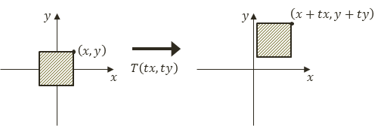

Figure 3-2. Translating a square by T(tx,ty)

* The scaling operator S(sx, sy), as illustrated by Figure 3-3, scales or resizes a given vertex position from (x,y) to (x×sx, y×sy). Notice that S(1,1) does not change the value of a given vertex position and is a convenient initial value for accumulating scaling operations.

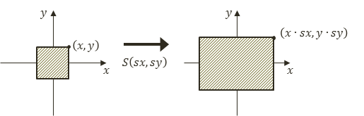

Figure 3-3. Scaling a square by S(sx,sy)

* The rotation operator R(θ), as illustrated in Figure 3-4, rotates a given vertex position with respect to the origin.

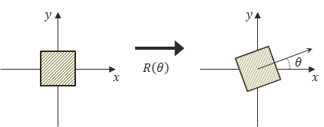

Figure 3-4. Rotating a square by R(θ)

In the case of rotation, R(0) does not change the value of a given vertex and is the convenient initial value for accumulating rotation operations. The values for θ are typically expressed in radians (and not degrees).

* The identity operator I does not affect a given vertex position. This operator is mostly used for initialization.

As an example, a 4×4 identity matrix looks like the following:



$I= \left[\begin{matrix}\begin{matrix}1 & 0 \\ 0 & 1\end{matrix} & \begin{matrix}0 & 0 \\ 0 & 0\end{matrix} \\ \begin{matrix}0 & 0 \\ 0 & 0\end{matrix} & \begin{matrix}1 & 0 \\ 0 & 1\end{matrix}\end{matrix}\right]$ Mathematically, a matrix transform operator operates on a vertex through a matrix-vector multiplication. To support this operation, a vertex position $p=(x,y,z)$ must be represented as a 4x1 vector as follows:



**Note** The z-component is the third dimension, or the depth information, of a vertex position. In most cases, you should leave the z-component to be 0.

For example, if position p' is the result of a translation operator T operating on the vertex position p, mathematically p' would be computed by the following:

$$p^{'}=T×p=Tp$$

### Concatenation of Matrix Operators

Multiple matrix operators can be *concatenated*, or combined, into a single operator while retaining the same transformation characteristics as the original operators. For example, you may want to apply the scaling operator S, followed by the rotation operator R, and finally the translation operator T, on a given vertex position, or to compute p' with the following:

$$p^{'}=TRSp$$

Alternatively, you can compute a new operator M by concatenating all the transform operators, as follows:

$$M=TRS$$

And then operate M on vertex position p, as follows, to produce identical results:

$$p^{'}=Mp$$

The M operator is a convenient and efficient way to record and re-apply the results of multiple operators.

Finally, notice that when working with transformation operators, the order of operation is important. For example, a scaling operation followed by a translation operation is in general different from a translation followed by a scaling, or, in general:

$ST≠TS$

## The glMatrix Library

The details of matrix operators and operations are nontrivial to say the least. Developing a complete matrix library is time-consuming and not the focus of this book. Fortunately, there are many well-developed and well-documented matrix libraries available in the public domain. The glMatrix library is one such example. To integrate this library into your source code structure, follow these steps:

1. Create a new folder under the src folder and name the new folder lib.
2. Go to <http://glMatrix.net>, as shown in Figure 3-5, and download, unzip, and store the resulting glMatrix.js source file into the new lib folder.

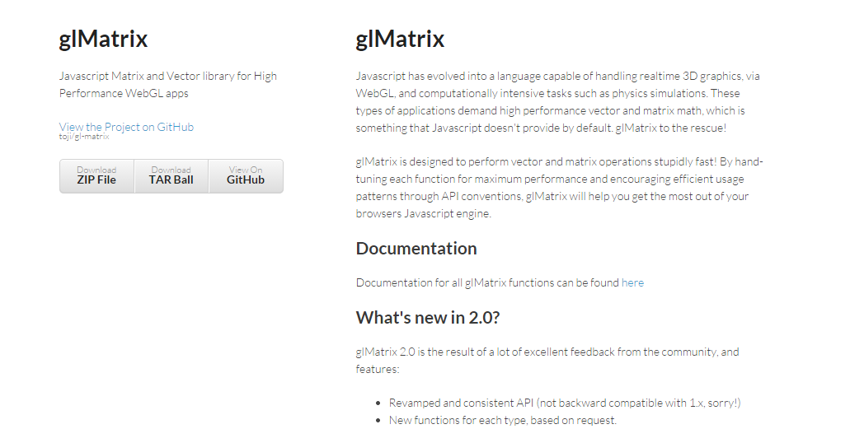

Figure 3-5. Downloading the glMatrix library

All projects in this book are based on glMatrix version 2.2.2.

1. As a library that must be accessible by both the game engine and the client game developer, you will load the source file in the main index.html by adding the following before the loading of my_game.js:

<!-- external library -->

<script type="text/javascript" src="src/lib/gl-matrix.js"></script>

<!-- our game -->

<script type="module" src="./src/my_game/my_game.js"></script>

## The Matrix Transform Project

This project introduces and demonstrates how to use transformation matrices as operators to manipulate the position, size, and orientation of Renderable objects drawn on the canvas. In this way, a Renderable can now be drawn to any location, with any size and any orientation. Figure 3-6 shows the output of running the Matrix Transform project. The source code to this project is defined in the chapter3/3.2.matrix_transform folder.

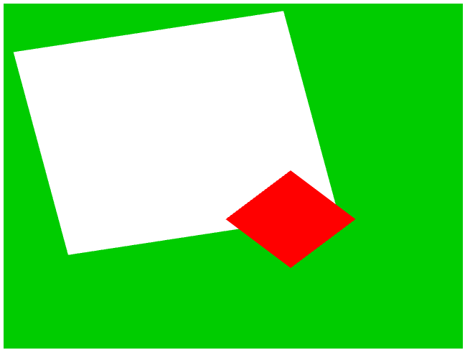

Figure 3-6. Running the Matrix Transform project

The goals of the project are as follows:

* To introduce transformation matrices as operators for drawing a Renderable
* To understand how to work with the transform operators to manipulate a Renderable

### Modify the Vertex Shader to Support Transforms

As discussed, matrix transform operators operate on vertices of geometries. The vertex shader is where all vertices are passed in from the WebGL context and is the most convenient location to apply the transform operations.

You will continue working with the previous project to support the transformation operator in the vertex shader.

1. Edit simple_vs.glsl to declare a uniform 4×4 matrix.

**Note** Recall from the discussion in Chapter 2 that glsl-files contain OpenGL Shading Language (GLSL) instructions that will be loaded to and executed by the GPU. You can find out more about GLSL by referring to the WebGL and OpenGL references provided at the end of Chapter 1.

// to transform the vertex position

uniform mat4 uModelXformMatrix;

Recall that the uniform keyword in a GLSL shader declares a variable with values that do not change for all the vertices within that shader. In this case, the uModelXformMatrix variable is the transform operator for all the vertices.

**Note** GLSL uniform variable names always begin with lowercase “u”, as in uModelXformMatrix.

1. In the main() function, apply the uModelXformMatrix to the currently referenced vertex position.

gl_Position = uModelXformMatrix * vec4(aVertexPosition, 1.0);

Notice that the operation follows directly from the discussion on matrix transformation operators. The reason for converting aVertexPosition to a vec4 is to support the matrix-vector multiplication.

With this simple modification, the vertex positions of the unit square will be operated on by the uModelXformMatrix operator, and thus the square can be drawn to different locations. The task now is to set up SimpleShader to load the appropriate transformation operator into uModelXformMatrix.

### Modify SimpleShader to Load the Transform Operator

Follow these steps:

1. Edit simple_shader.js and add an instance variable to hold the reference to the uModelXformMatrix matrix in the vertex shader.

this.mModelMatrixRef = null;

1. At the end of the SimpleShader constructor under step E, after setting the reference to uPixelColor, add the following code to initialize this reference:

// Step E: Gets a reference to the uniform variables in the fragment shader

this.mPixelColorRef = gl.getUniformLocation(this.mCompiledShader, "uPixelColor");

this.mModelMatrixRef = gl.getUniformLocation(this.mCompiledShader, "uModelXformMatrix");

1. Modify the activate() function to receive a second parameter and load the value to uModelXformMatrix via mModelMatrixRef:

activate(pixelColor, trsMatrix) {

let gl = glSys.get();

gl.useProgram(this.mCompiledShader);

… identical to previous code …

// load uniforms

gl.uniform4fv(this.mPixelColorRef, pixelColor);

gl.uniformMatrix4fv(this.mModelMatrixRef, false, trsMatrix);

}

The gl.uniformMatrix4fv() function copies the values from trsMatrix to the vertex shader location identified by this.mModelMatrixRef or the uModelXfromMatrix operator in the vertex shader. The name of the variable, trsMatrix, signifies that it should be a matrix operator containing the concatenated result of translation (T), rotation (R), and scaling (S), or TRS.

### Modify Renderable Class to Set the Transform Operator

Edit renderable.js to modify the draw() function to receive and to forward a transform operator to the mShader.activate() function to be loaded to the GLSL shader.

draw(trsMatrix) {

let gl = glSys.get();

this.mShader.activate(this.mColor, trsMatrix);

gl.drawArrays(gl.TRIANGLE_STRIP, 0, 4);

}

In this way, when the vertices of the unit square are processed by the vertex shader, the uModelXformMatrix will contain the proper operator for transforming the vertices and thus drawing the square at the desired location, size, and rotation.

### Testing the Transforms

Now that the game engine supports transformation, you need to modify the client code to draw with it.

1. Edit my_game.js; after step C, instead of activating and drawing the two squares, replace steps C1 and C2 to create a new identity transform operator, trsMatrix.

// create a new identify transform operator

let trsMatrix = mat4.create();

1. Compute the concatenation of matrices to a single transform operator that implements translation (T), rotation (R), and scaling (S), or TRS.

// Step D: compute the white square transform

mat4.translate(trsMatrix, trsMatrix, vec3.fromValues(-0.25, 0.25, 0.0));

mat4.rotateZ(trsMatrix, trsMatrix, 0.2); // rotation is in radian

mat4.scale(trsMatrix, trsMatrix, vec3.fromValues(1.2, 1.2, 1.0));

// Step E: draw the white square with the computed transform

this.mWhiteSq.draw(trsMatrix);

Step D concatenates T(-0.25, 0.25), moving to the left and up; with R(0.2), rotating clockwise by 0.2 radians; and S(1.2, 1.2), increasing size by 1.2 times. The concatenation order applies the scaling operator first, followed by rotation, with translation being the last operation, or trsMatrix=TRS. In step E the Renderable object is drawn with the trsMatrix operator or a 1.2×1.2 white rectangle slightly rotated and located somewhat to the upper left from the center.

1. Finally, step F defines the trsMatrix operator that to draw a 0.4×0.4 square that is rotated by 45 degrees and located slightly toward the lower right from the center of the canvas and step G draws the red square.

// Step F: compute the red square transform

mat4.identity(trsMatrix); // restart

mat4.translate(trsMatrix, trsMatrix, vec3.fromValues(0.25, -0.25, 0.0));

mat4.rotateZ(trsMatrix, trsMatrix, -0.785); // rotation of about -45-degrees

mat4.scale(trsMatrix, trsMatrix, vec3.fromValues(0.4, 0.4, 1.0));

// Step G: draw the red square with the computed transform

this.mRedSq.draw(trsMatrix);

## Observations

Run the project, and you should see the corresponding white and red rectangles drawn on the canvas. You can gain some intuition of the operators by changing the values; for example, move and scale the squares to different locations with different sizes. You can try changing the order of concatenation by moving the corresponding line of code; for example, move mat4.scale() to before mat4.translate(). You will notice that, in general, the transformed results do not correspond to your intuition. In this book, you will always apply the transformation operators in the fixed TRS order. This ordering of transformation operators corresponds to typical human intuition. The TRS operation order is followed by most, if not all, graphical APIs and applications that support transformation operations.

Now that you understand how to work with the matrix transformation operators, it is time to abstract them and hide their details.

# Encapsulating the Transform Operator

In the previous project, the transformation operators were computed directly based on the matrices. While the results were important, the computation involves distracting details and repetitive code. This project guides you to follow good coding practices to encapsulate the transformation operators by hiding the detailed computations with a class. In this way, you can maintain the modularity and accessibility of the game engine by supporting further expansion while maintaining programmability.

## The Transform Objects Project

This project defines the Transform class to provide a logical interface for manipulating and hiding the details of working with the matrix transformation operators. Figure 3-7 shows the output of running the Matrix Transform project. Notice that the output of this project is identical to that from the previous project. The source code to this project is defined in the chapter3/3.3.transform_objects folder.



Figure 3-7. Running the Transform Objects project

The goals of the project are as follows:

* To create the Transform class to encapsulate the matrix transformation functionality
* To integrate the Transform class into the game engine
* To demonstrate how to work with Transform objects

### The Transform Class

Continue working with the previous project.

1. Define the Transform class in the game engine by creating a new source code file in the src/engine folder, and name the file transform.js.
2. Define the constructor to initialize instance variables that correspond to the operators: mPosition for translation, mScale for scaling, and mRotationInRad for rotation.

class Transform {

constructor() {

this.mPosition = vec2.fromValues(0, 0); // this is the translation

this.mScale = vec2.fromValues(1, 1); // this is the width (x) and height (y)

this.mRotationInRad = 0.0; // in radians!

}

… implementation to follow …

}

1. Add getters and setters for the values of each operator.

// Position getters and setters

setPosition(xPos, yPos) { this.setXPos(xPos); this.setYPos(yPos); }

getPosition() { return this.mPosition; } = function() { return this.mPosition;};

// … additional get and set functions for position not shown

// Size setters and getters

setSize(width, height) {

this.setWidth(width);

this.setHeight(height);

}

getSize() { return this.mScale; }

// … additional get and set functions for size not shown

// Rotation getters and setters

setRotationInRad(rotationInRadians) {

this.mRotationInRad = rotationInRadians;

while (this.mRotationInRad > (2 * Math.PI)) {

this.mRotationInRad -= (2 * Math.PI);

}

}

setRotationInDegree(rotationInDegree) {

this.setRotationInRad(rotationInDegree * Math.PI / 180.0);

}

// … additional get and set functions for rotation not shown

1. Define the getTRSMatrix() function to compute and return the concatenated transform operator, TRS.

getTRSMatrix() {

// Creates a blank identity matrix

let matrix = mat4.create();

// Step A: compute translation, for now z is always at 0.0

mat4.translate(matrix, matrix, vec3.fromValues(this.getXPos(), this.getYPos(), 0.0));

// Step B: concatenate with rotation.

mat4.rotateZ(matrix, matrix, this.getRotationInRad());

// Step C: concatenate with scaling

mat4.scale(matrix, matrix, vec3.fromValues(this.getWidth(), this.getHeight(), 1.0));

return matrix;

}

This code is similar to steps D and F in my_game.js from the previous project. The concatenated operator TRS performs scaling first, followed by rotation, and lastly by translation.

1. Finally, remember to export the newly defined Transform class.

export default Transform;

### The Transformable Renderable Class

By integrating the Transform class, a Renderable object can now have a position, size (scale), and orientation (rotation). This integration can be easily accomplished through the following steps.

1. Edit renderable.js and add a new instance variable to reference a Transform object in the constructor.

this.mXform = new Transform(); // transform operator for the object

1. Define an accessor for the transform operator.

getXform() { return this.mXform; }

1. Modify the draw() function to pass the trsMatrix operator of the mXform object to activate the shader before drawing the unit square.

draw() {

let gl = glSys.get();

this.mShader.activate(this.mColor, this.mXform.getTRSMatrix());

gl.drawArrays(gl.TRIANGLE_STRIP, 0, 4);

}

With this simple modification, Renderable objects will be drawn with characteristics defined by the values of its own transformation operators.

### Modify the Engine Access File to Export Transform

It is important to maintain the engine access file, index.js, up to date such that the newly defined Transform class can be accessed by the game developer.

1. Edit index.js; import from the newly define transform.js file.

// general utiities

import Transform from "./transform.js";

import Renderable from "./renderable.js";

1. Export Transform for client’s access.

export default {

// Util classes

Transform, Renderable,

// functions

init, clearCanvas

}

### Modify Drawing to Support Transform Object

To test the Transform and the improved Renderable classes, the MyGame constructor can be modified to set the transform operators in each of the Renderable objects accordingly.

// Step D: sets the white Renderable object's transform

this.mWhiteSq.getXform().setPosition(-0.25, 0.25);

this.mWhiteSq.getXform().setRotationInRad(0.2); // In Radians

this.mWhiteSq.getXform().setSize(1.2, 1.2);

// Step E: draws the white square (transform behavior in the object)

this.mWhiteSq.draw();

// Step F: sets the red square transform

this.mRedSq.getXform().setXPos(0.25); // to show alternative to setPosition

this.mRedSq.getXform().setYPos(-0.25); // it is possible to setX/Y separately

this.mRedSq.getXform().setRotationInDegree(45); // this is in Degree

this.mRedSq.getXform().setWidth(0.4); // to show alternative to setSize

this.mRedSq.getXform().setHeight(0.4); // that it is possible to width/height separately

// Step G: draw the red square (transform in the object)

this.mRedSq.draw();

Run the project to observe identical output as from the previous project. You can now create and draw a Renderable at any location in the canvas, and the transform operator has now been properly encapsulated.

# The Camera Transform and Viewports

When designing and building a video game, the game designers and programmers must be able to focus on the intrinsic logic and presentation. To facilitate these aspects, it is important that the designers and programmers can formulate solutions in a convenient dimension and space.

For example, continuing with the soccer game idea, consider the task of creating a soccer field. How big is the field? What is the unit of measurement? In general, when building a game world, it is often easier to design a solution by referring to the real world. In the real world, soccer fields are around 100 meters long. However, in the game or graphics world, units are arbitrary. So, a simple solution may be to create a field that is 100 units in meters and a coordinate space where the origin is located at the center of the soccer field. In this way, opposing sides of the fields can simply be determined by the sign of the x-value, and drawing a player at location (0, 1) would mean drawing the player 1 meter to the right from the center of the soccer field.

A contrasting example would be when building a chess-like board game. It may be more convenient to design the solution based on a unitless n×n grid with the origin located at the lower-left corner of the board. In this scenario, drawing a piece at location (0, 1) would mean drawing the piece at the location one cell or unit toward the right from the lower-left corner of the board. As will be discussed, the ability to define specific coordinate systems is often accomplished by computing and working with a matrix representing the view from a camera.

In all cases, to support a proper presentation of the game, it is important to allow the programmer to control the drawing of the contents to any location on the canvas. For example, you may want to draw the soccer field and players to one subregion and draw a mini-map into another subregion. These axis-aligned rectangular drawing areas or subregions of the canvas are referred to as viewports.

In this section, you will learn about coordinate systems and how to use the matrix transformation as a tool to define a drawing area that conforms to the fixed ±1 drawing range of the WebGL.

## Coordinate Systems and Transformations

A 2D coordinate system uniquely identifies every position on a 2D plane. All projects in this book follow the Cartesian coordinate system where positions are defined according to perpendicular distances from a reference point known as the *origin,* as illustrated in Figure 3-8. The perpendicular directions for measuring the distances are known as the *major axes*. In 2D space, these are the familiar x- and y-axes.

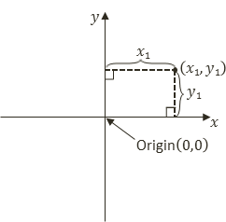

Figure 3-8. Working with a 2D Cartesian coordinate system

### Modeling and Normalized Device Coordinate Systems

So far in this book, you have experience with two distinct coordinate systems. The first is the coordinate system that defines the vertices for the 1×1 square in the vertex buffer. This is referred to as the Modeling Coordinate System, which defines the Model Space. The Model Space is unique for each geometric object, as in the case of the unit square. The Model Space is defined to describe the geometry of a single model. The second coordinate system that you have worked with is the one that WebGL draws to, where the x/y-axes ranges are bounded to ±1.0. This is known as the Normalized Device Coordinates (NDC) System. As you have experienced, WebGL always draws to the NDC space and that the contents in the ±1.0 range cover all the pixels in the canvas.

The Modeling transform, typically defined by a matrix transformation operator, is the operation that transforms geometries from its Model Space into another coordinate space that is convenient for drawing. In the previous project, the uModelXformMatrix variable in simple_vs.glsl is the Modeling transform. As illustrated in Figure 3-9, in that case, the Modeling transform transformed the unit square into the WebGL’s NDC space. The rightmost arrow annotated with the Fixed Mapping label in Figure 3-9 that points from WebGL NDC to Canvas Coordinates signifies that WebGL always displays the entire content of the NDC space in the canvas.

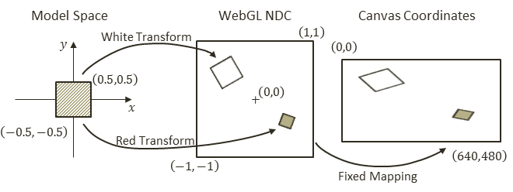

Figure 3-9. Transforming the square from Model to NDC space

### The World Coordinate System

Although it is possible to draw to any location with the Modeling transform, the disproportional scaling that draws squares as rectangles is still a problem. In addition, the fixed -1.0 and 1.0 NDC space is not a convenient coordinate space for designing games. The World Coordinate (WC) System describing a convenient World Space that resolves these issues. For convenience and readability, in the rest of this book WC will also be used to refer to the World Space that is defined by a specific World Coordinate system.

As illustrated in Figure 3-10, with a WC instead of the fixed NDC space, Modeling transforms can transform models into a convenient coordinate system that lends itself to game designs. For the soccer game example, the World Space dimension can be the size of the soccer field. As in any Cartesian coordinate system, the WC system is defined by a reference position and its width and height. The reference position can either be the lower-left corner or the center of the WC.

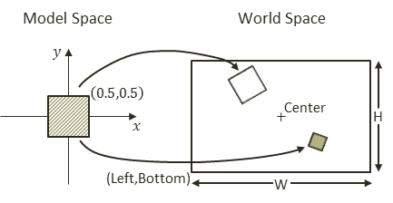

Figure 3-10. Working with a World Coordinate (WC) System

The WC is a convenient coordinate system for designing games. However, it is not the space that WebGL draws to. For this reason, it is important to transform from WC to NDC. In this book, this transform is referred to as the Camera transform. To accomplish this transform, you will have to construct an operator to align WC center with that of the NDC (the origin), and then to scale the WC WxH dimension to match the NDC width and height. Note that the NDC space has a constant range of -1 to +1 and thus a fixed dimension of 2x2. In this way, the Camera transform is simply a translation followed by a scaling operation:

$$M=S(\frac{2}{W},\frac{2}{H})T(-center.x, -center.y)$$

In this case, (center.x, center.y) and WxH are the center and the dimension of the WC system.

### The Viewport

A viewport is an area to be drawn to. As you have experienced, by default WebGL defines the entire canvas to be the viewport for drawing. Conveniently, WebGL provides a function to override this default behavior.

gl.viewport(

x, // x position of bottom-left corner of the area to be drawn

y, // y position of bottom-left corner of the area to be drawn

width, // width of the area to be drawn

height // height of the area to be drawn

);

The gl.viewport() function defines a viewport for all subsequent drawings. Figure 3-11 illustrates the Camera transform and drawing with a viewport.

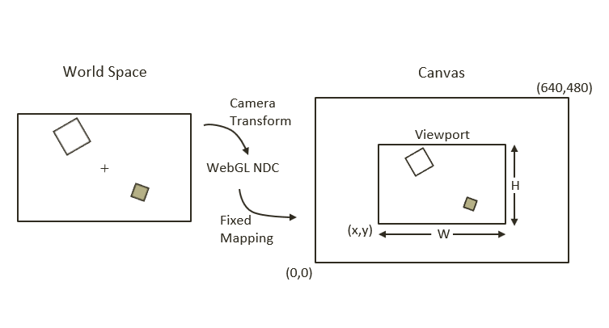

Figure 3-11. Working with the WebGL viewport

## The Camera Transform and Viewport Project

This project demonstrates how to use the Camera transform to draw from any desired coordinate location to any subregion of the canvas, or a viewport. Figure 3-12 shows the output of running the Camera Transform and Viewport project. The source code to this project is defined in the chapter3/3.4.camera_transform_and_viewport folder.

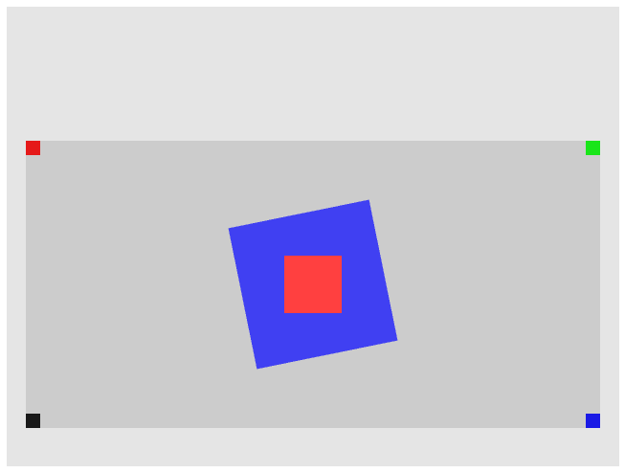

Figure 3-12. Running the Camera Transform and Viewport project

The goals of the project are as follows:

* To understand the different coordinate systems
* To experience working with a WebGL viewport to define and draw to different subregions within the canvas
* To understand the Camera transform
* To begin drawing to the user-defined World Coordinate System

You are now ready to modify the game engine to support the Camera transform to define your own WC and the corresponding viewport for drawing. The first step is to modify the shaders to support a new transform operator.

### Modify the Vertex Shader to Support the Camera Transform

Relatively minor changes are required to add the support for the Camera transform.

1. Edit simple_vs.glsl to add a new uniform matrix operator to represent the Camera transform.

uniform mat4 uCameraXformMatrix;

1. Make sure to apply the operator on the vertex positions in the vertex shader program.

gl_Position = uCameraXformMatrix * uModelXformMatrix * vec4(aVertexPosition, 1.0)

Recall that the order of matrix operations is important. In this case, the uModelXformMatrix first transforms the vertex positions from Model Space to WC, and then the uCameraXformMatrix transforms from WC to NDC. The order of uModelxformMatrix and uCameraXformMatrix cannot be switched.

### Modify SimpleShader to Support the Camera Transform

The SimpleShader object must be modified to access and pass the Camera transform matrix to the vertex shader.

1. Edit simple_shader.js and in the constructor add an instance variable for storing the reference to the Camera transform operator in simple_vs.glsl.

this.mCameraMatrixRef = null;

1. At the end of the SimpleShader constructor, retrieve the reference to the Camera transform operator, uCameraXformMatrix, after retrieving those for the uModelXformMatrix and uPixelColor.

// Step E: Gets a reference to the uniform variables in the fragment shader

this.mPixelColorRef = gl.getUniformLocation(this.mCompiledShader, "uPixelColor");

this.mModelMatrixRef = gl.getUniformLocation(this.mCompiledShader, "uModelXformMatrix");

this.mCameraMatrixRef = gl.getUniformLocation(this.mCompiledShader, "uCameraXformMatrix");

1. Modify the activate function to receive a Camera matrix and pass it to the shader.

activate(pixelColor, trsMatrix, cameraMatrix) {

let gl = glSys.get();

gl.useProgram(this.mCompiledShader);

… identical to previous code …

// load uniforms

gl.uniform4fv(this.mPixelColorRef, pixelColor);

gl.uniformMatrix4fv(this.mModelMatrixRef, false, trsMatrix);

gl.uniformMatrix4fv(this.mCameraMatrixRef, false, cameraMatrix);

}

As you have seen previously, the gl.uniformMatrix4fv() function copies the content of cameraMatrix to the uCameraXformMatrix operator.

### Modify Renderable to Support the Camera Transform

Recall that shaders are activated in the draw() function of the Renderable class; as such, Renderable must also be modified to receive and pass cameraMatrix to activate the shader.

draw(cameraMatrix) {

let gl = glSys.get();

this.mShader.activate(this.mColor, this.mXform.getTRSMatrix(), cameraMatrix);

gl.drawArrays(gl.TRIANGLE_STRIP, 0, 4);

}

It is now possible to set up a WC for drawing and define a subarea in the canvas to draw to.

### Design the Scene

As illustrated in Figure 3-13, for testing purposes, a World Space (WC) will be defined to be centered at (20, 60) with a dimension of 20×10. Two rotated squares, a 5x5 blue square and a 2×2 red square, will be drawn at the center of the WC. To verify the coordinate bounds, a 1×1 square with a distinct color will be drawn at each of the WC corners.

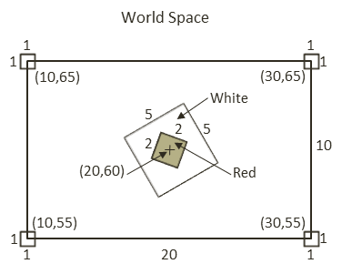

Figure 3-13. Designing a WC to support drawing

As illustrated in Figure 3-14, the WC will be drawn into a viewport with the lower-left corner located at (20, 40) and a dimension of 600×300 pixels. It is important to note that in order for squares to show up proportionally, the width-to-height aspect ratio of the WC must match that of the viewport. In this case, the WC has a 20:10 aspect ratio, and this 2:1 ratio matches that of the 600:300 of the viewport.

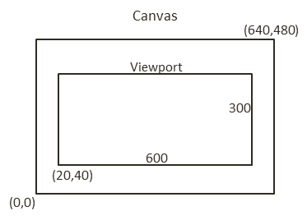

Figure 3-14. Drawing the WC to the viewport

Note that the details of the WC, centered at (20, 60) with dimension 20x10, and the viewport, lower-left corner at (20, 40) and dimension of 600x300, are chosen rather randomly. These are simply reasonable values that can demonstrate the correctness of the implementation.

#### Implement the Design

The MyGame class will be modified to implement the design.

1. Edit my_game.js. In the constructor perform step A to initialize the game engine and step B to create six Renderable objects (two to be drawn at the center, with four at each corner of the WC) with corresponding colors.

constructor(htmlCanvasID) {

// Step A: Initialize the game engine

engine.init(htmlCanvasID);

// Step B: Create the Renderable objects:

this.mBlueSq = new engine.Renderable();

this.mBlueSq.setColor([0.25, 0.25, 0.95, 1]);

this.mRedSq = new engine.Renderable();

this.mRedSq.setColor([1, 0.25, 0.25, 1]);

this.mTLSq = new engine.Renderable();

this.mTLSq.setColor([0.9, 0.1, 0.1, 1]);

this.mTRSq = new engine.Renderable();

this.mTRSq.setColor([0.1, 0.9, 0.1, 1]);

this.mBRSq = new engine.Renderable();

this.mBRSq.setColor([0.1, 0.1, 0.9, 1]);

this.mBLSq = new engine.Renderable();

this.mBLSq.setColor([0.1, 0.1, 0.1, 1]);

… implementation to follow …

}

1. Steps C and D clear the entire canvas, setup the viewport, and clear the viewport to a different color.

// Step C: Clear the entire canvas first

engine.clearCanvas([0.9, 0.9, 0.9, 1]);

// get access to the gl connection to the GPU

let gl = glSys.get();

// Step D: Setting up Viewport

// Step D1: Set up the viewport: area on canvas to be drawn

gl.viewport(

20, // x position of bottom-left corner of the area to be drawn

40, // y position of bottom-left corner of the area to be drawn

600, // width of the area to be drawn

300); // height of the area to be drawn

// Step D2: set up the corresponding scissor area to limit clear area

gl.scissor(

20, // x position of bottom-left corner of the area to be drawn

40, // y position of bottom-left corner of the area to be drawn

600, // width of the area to be drawn

300); // height of the area to be drawn

// Step D3: enable the scissor area, clear, and then disable the scissor area

gl.enable(gl.SCISSOR_TEST);

engine.clearCanvas([0.8, 0.8, 0.8, 1.0]); // clear the scissor area

gl.disable(gl.SCISSOR_TEST);

Step D1 defines the viewport, and step D2 defines a corresponding scissor area. The scissor area tests and limits the area to be cleared. Since the testing involved in gl.scissor() is computationally expensive, it is disabled immediately after use.

1. Step E defines the WC with the Camera transform by concatenating the proper scaling and translation operators.

// Step E: Set up camera transform matrix

// assume camera position and dimension

let cameraCenter = vec2.fromValues(20, 60);

let wcSize = vec2.fromValues(20, 10);

let cameraMatrix = mat4.create();

// Step E1: following the translation, scale to: (-1, -1) to (1, 1): a 2x2 square at origin

mat4.scale(cameraMatrix, mat4.create(), vec3.fromValues(2.0/wcSize[0], 2.0/wcSize[1], 1.0));

// Step E2: first operation to perform is to translate camera center to the origin

mat4.translate(cameraMatrix, cameraMatrix, vec3.fromValues(-cameraCenter[0],

-cameraCenter[1], 0));

Step E1 defines the scaling operator, S(2/W, 2/H), to scale the WC WxH to the NDC 2x2 dimension and step E2 defines the translation operator, T(-center.x, -center.y), to align the WC with the NDC center. Note that the concatenation order implements the translation first followed by the scaling operator. This is precisely the Camera transform described earlier that defines the WC as follows:

1. *Center*: (20,60)
2. *Top-left corner*: (10, 65)
3. *Top-right corner*: (30, 65)
4. *Bottom-right corner*: (30, 55)
5. *Bottom-left corner*: (10, 55)

Recall that the order of multiplication is important and that the order of scaling and translation operators cannot be swapped.

1. Set up the slightly rotated 5x5 blue square at the center of WC and draw with the Camera transform operator, cameraMatrix.

// Step F: Draw the blue square

// Center Blue, slightly rotated square

this.mBlueSq.getXform().setPosition(20, 60);

this.mBlueSq.getXform().setRotationInRad(0.2); // In Radians

this.mBlueSq.getXform().setSize(5, 5);

this.mBlueSq.draw(cameraMatrix);

1. Now draw the other five squares, first the 2x2 in the center and one each at a corner of the WC.

// Step G: Draw the center and the corner squares

// center red square

this.mRedSq.getXform().setPosition(20, 60);

this.mRedSq.getXform().setSize(2, 2);

this.mRedSq.draw(cameraMatrix);

// top left

this.mTLSq.getXform().setPosition(10, 65);

this.mTLSq.draw(cameraMatrix);

// top right

this.mTRSq.getXform().setPosition(30, 65);

this.mTRSq.draw(cameraMatrix);

// bottom right

this.mBRSq.getXform().setPosition(30, 55);

this.mBRSq.draw(cameraMatrix);

// bottom left

this.mBLSq.getXform().setPosition(10, 55);

this.mBLSq.draw(cameraMatrix);

Run this project and observe the distinct colors at the four corners: the top left (mTLSq) in red, the top right (mTRSq) in green, the bottom right (mBRSq) in blue, and the bottom left (mBLSq) in dark gray. Change the locations of the corner squares to verify that the center positions of these squares are located in the bounds of the WC, and thus only one-quarter of the squares are actually visible. For example, set mBlSq to (12, 57) to observe the dark-gray square is actually four times the size. This observation verifies that the areas of the squares outside of the viewport/scissor area are clipped by WebGL.

Although lacking proper abstraction, it is now possible to define any convenient WC system and any rectangular subregions of the canvas for drawing. With the Modeling and Camera transformations, a game programmer can now design a game solution based on the semantic needs of the game and ignore the irrelevant WebGL NDC drawing range. However, the code in the MyGame class is complicated and can be distracting. As you have seen so far, the important next step is to define an abstraction to hide the details of Camera transform matrix computation.

# The Camera

The Camera transform allows the definition of a WC. In the physical world, this is analogous to taking a photograph with the camera. The center of the viewfinder of your camera is the center of the WC, and the width and height of the world visible through the viewfinder are the dimensions of WC. With this analogy, the act of taking the photograph is equivalent to computing the drawing of each object in the WC. Lastly, the viewport describes the location to display the computed image.

## The Camera Objects Project

This project demonstrates how to abstract the Camera transform and the viewport to hide the details of matrix computation and WebGL configurations. Figure 3-15 shows the output of running the Camera Objects project; notice the output of this project is identical to that from the previous project. The source code to this project is defined in the chapter3/3.5.camera_objects folder.



Figure 3-15. Running the Camera Objects project

The goals of the project are as follows:

* To define the Camera class to encapsulate the definition of WC and the viewport functionality
* To integrate the Camera class into the game engine
* To demonstrate how to work with a Camera object

### The Camera Class

The Camera class must encapsulate the functionality defined by the scaling and translation operators in the MyGame constructor from the previous example. A clean and reusable class design should be completed with appropriate getter and setter functions.

1. Define the Camera class in the game engine by creating a new source file in the src/engine folder, and name the file camera.js.
2. Add the constructor for Camera.

class Camera {

constructor(wcCenter, wcWidth, viewportArray) {

// WC and viewport position and size

this.mWCCenter = wcCenter;

this.mWCWidth = wcWidth;

this.mViewport = viewportArray; // [x, y, width, height]

// Camera transform operator

this.mCameraMatrix = mat4.create();

// background color

this.mBGColor = [0.8, 0.8, 0.8, 1]; // RGB and Alpha

}

… implementation to follow …

}

The Camera defines the WC center and width, the viewport, the Camera transform operator, and a background color. Take note of the following:

1. The mWCCenter is a vec2 (vec2 is defined in the glMatrix library). It is a float array of two elements. The first element, index position 0, of vec2 is the x, and the second element, index position 1, is the y position.
2. The four elements of the viewportArray are the x and y positions of the lower-left corner and the width and height of the viewport, in that order. This compact representation of the viewport keeps the number of instance variables to a minimum and helps keep the Camera class manageable.
3. The mWCWidth is the width of the WC. To guarantee a matching aspect ratio between WC and the viewport, the height of the WC is always computed from the aspect ratio of the viewport and mWCWidth.
4. mBgColor is an array of four floats representing the red, green, blue, and alpha components of a color.
5. Outside of the Camera class definition, define enumerated indices for accessing the viewportArray.

const eViewport = Object.freeze({

eOrgX: 0,

eOrgY: 1,

eWidth: 2,

eHeight: 3

});

**Note** Enumerated elements have names that begin with lowercase “e”, as in eVewport and eOrgX.

1. Define the function to compute the WC height based on the aspect ratio of the viewport.

getWCHeight() {

// viewportH/viewportW

let ratio = this.mViewport[eViewport.eHeight] / this.mViewport[eViewport.eWidth];

return this.getWCWidth() * ratio;

}

1. Add getters and setters for the instance variables.

setWCCenter(xPos, yPos) {

this.mWCCenter[0] = xPos;

this.mWCCenter[1] = yPos;

}

getWCCenter() { return this.mWCCenter; }

setWCWidth(width) { this.mWCWidth = width; }

setViewport(viewportArray) { this.mViewport = viewportArray; }

getViewport() { return this.mViewport; }

setBackgroundColor(newColor) { this.mBGColor = newColor; }

getBackgroundColor() { return this.mBGColor; }

1. Create a function to set the viewport and compute the Camera transform operator for this Camera:

// Initializes the camera to begin drawing

setViewAndCameraMatrix() {

let gl = glSys.get();

// Step A: Configure the viewport

… implementation to follow …

// Step B: compute the Camera Matrix

… implementation to follow …

}

Note that this function is called setViewAndCameraMatrix() because it configures WebGL to draw to the desire viewport and sets up the Camera transform operator. The following explains the details of steps A and B.

1. The code to configure the viewport under step A is as follows:

// Step A1: Set up the viewport: area on canvas to be drawn

gl.viewport(this.mViewport[0], // x position of bottom-left corner of the area to be drawn

this.mViewport[1], // y position of bottom-left corner of the area to be drawn

this.mViewport[2], // width of the area to be drawn

this.mViewport[3]); // height of the area to be drawn

// Step A2: set up the corresponding scissor area to limit the clear area

gl.scissor(this.mViewport[0], // x position of bottom-left corner of the area to be drawn

this.mViewport[1], // y position of bottom-left corner of the area to be drawn

this.mViewport[2], // width of the area to be drawn

this.mViewport[3]);// height of the area to be drawn

// Step A3: set the color to be clear

gl.clearColor(this.mBGColor[0], this.mBGColor[1], this.mBGColor[2], this.mBGColor[3]);

// set the color to be cleared

// Step A4: enable the scissor area, clear, and then disable the scissor area

gl.enable(gl.SCISSOR_TEST);

gl.clear(gl.COLOR_BUFFER_BIT);

gl.disable(gl.SCISSOR_TEST);

Notice the similarity of these steps to the viewport setup code in MyGame of the previous example. The only difference is the proper references to the instance variables via this.

1. The code to set up the Camera transform operator under step B is as follows.

// Step B: Compute the Camera Matrix  
let center = this.getWCCenter();  
  
// Step B1: following the translation, scale to: (-1, -1) to (1, 1): a 2x2 square at origin  
mat4.scale(this.mCameraMatrix, mat4.create(), vec3.fromValues(2.0 / this.getWCWidth(), 2.0 / this.getWCHeight(), 1.0));  
  
// Step B2: first operation to perform is to translate camera center to the origin  
mat4.translate(this.mCameraMatrix, this.mCameraMatrix, vec3.fromValues(-center[0], -center[1], 0));

Once again, this code is similar to the MyGame constructor from the previous example.

1. Define a function to access the computed camera matrix.

getCameraMatrix() { return this.mCameraMatrix; }

1. Finally, remember to export the newly defined Camera class.

export default Camera.

### Modify Renderable to Support the Camera Class

The draw() function of the Renderable class must be modified to receive the newly defined Camera in order to access the computed camera matrix.

draw(camera) {

let gl = glSys.get();

this.mShader.activate(this.mColor, this.mXform.getTRSMatrix(), camera.getCameraMatrix());

gl.drawArrays(gl.TRIANGLE_STRIP, 0, 4);

}

### Modify the Engine Access File to Export Camera

It is important to maintain the engine access file, index.js, up to date such that the newly defined Camera class can be accessed by the game developer.

1. Edit index.js; import from the newly define camera.js file.

// general utiities

import Camera from "./camera.js";

import Transform from "./transform.js";

import Renderable from "./renderable.js";

1. Export Camera for client’s access.

export default {

// Util classes

Camera, Transform, Renderable,

// functions

init, clearCanvas

}

### Test the Camera

With the Camera class properly defined, testing it from my_game.js is straightforward.

1. Edit my_game.js; after the initialization of the game engine in step A, create an instance of the Camera object with settings that define the WC and viewport from the previous project in step B.

class MyGame {

constructor(htmlCanvasID) {

// Step A: Initialize the game engine

engine.init(htmlCanvasID);

// Step B: Setup the camera

this.mCamera = new engine.Camera(

vec2.fromValues(20, 60), // center of the WC

20, // width of WC

[20, 40, 600, 300] // viewport (orgX, orgY, width, height)

);

… implementation to follow …

}

1. Continue with the creation of the six Renderable objects, and the clearing of the canvas in steps C and D.

// Step C: Create the Renderable objects:

this.mBlueSq = new engine.Renderable();

this.mBlueSq.setColor([0.25, 0.25, 0.95, 1]);

this.mRedSq = new engine.Renderable();

this.mRedSq.setColor([1, 0.25, 0.25, 1]);

this.mTLSq = new engine.Renderable();

this.mTLSq.setColor([0.9, 0.1, 0.1, 1]);

this.mTRSq = new engine.Renderable();

this.mTRSq.setColor([0.1, 0.9, 0.1, 1]);

this.mBRSq = new engine.Renderable();

this.mBRSq.setColor([0.1, 0.1, 0.9, 1]);

this.mBLSq = new engine.Renderable();

this.mBLSq.setColor([0.1, 0.1, 0.1, 1]);

// Step D: Clear the canvas

engine.clearCanvas([0.9, 0.9, 0.9, 1]); // Clear the canvas

1. Now, call the setViewAndCameraMatrix() function of the Camera object in to configure the WebGL viewport and compute the camera matrix in step E, and draw all the Renderables using the Camera object in step F and G.

// Step E: Starts the drawing by activating the camera

this.mCamera.setViewAndCameraMatrix();

// Step F: Draw the blue square

// Center Blue, slightly rotated square

this.mBlueSq.getXform().setPosition(20, 60);

this.mBlueSq.getXform().setRotationInRad(0.2); // In Radians

this.mBlueSq.getXform().setSize(5, 5);

this.mBlueSq.draw(this.mCamera);

// Step G: Draw the center and the corner squares

// center red square

this.mRedSq.getXform().setPosition(20, 60);

this.mRedSq.getXform().setSize(2, 2);

this.mRedSq.draw(this.mCamera);

// top left

this.mTLSq.getXform().setPosition(10, 65);

this.mTLSq.draw(this.mCamera);

// top right

this.mTRSq.getXform().setPosition(30, 65);

this.mTRSq.draw(this.mCamera);

// bottom right

this.mBRSq.getXform().setPosition(30, 55);

this.mBRSq.draw(this.mCamera);

// bottom left

this.mBLSq.getXform().setPosition(10, 55);

this.mBLSq.draw(this.mCamera);

The mCamera object is passed to the draw() function of the Renderable objects such that the Camera matrix operator can be retrieved and used to activate the shader.

# Summary

In this chapter, you learned how to create a system that can support the drawing of many objects. The system is composed of three parts: the objects, the details of each object, and the display of the objects on the browser’s canvas. The objects are encapsulated by the Renderable, which uses a Transform to capture its details—the position, size, and rotation. The particulars of displaying the objects are defined by the Camera, where objects at specific locations can be displayed at desirable subregions on the canvas.

You also learned that objects are all drawn relative to a World Space or WC, a convenient coordinate system. A WC is defined for scene compositions based on coordinate transformations. Lastly, the Camera transform is used to select which portion of the WC to actually display on the canvas within a browser. This can be achieved by defining an area that is viewable by the Camera and using the viewport functionality provided by WebGL.

As you built the drawing system, the game engine source code structure has been consistently refactored into abstracted and encapsulated components. In this way, the source code structure continues to support further expansion including additional functionality which will be discussed in the next chapter.